

INSTITUTE OF ECE ECA14 – EMBEDDED SYSTEMS
List of Experiments
Exp. No | Name of the Experiment | Remarks
1 | Flashing of Led using AT89C51 Microcontroller using Proteus
2 | Generation of Square Wave using Proteus
3 | Stepper Motor Using AT89C51 using Proteus
4 | 7 Segment Display Using AT89C51 using Proteus
5 | Arduino based Manual Electronic Counter using Proteus
6 | Arduino to 16x2 LCD Display using Proteus
7 | Serial Communication using Arduino with Proteus
8 | Gas Sensor MQ-2 in Proteus using Arduino
9 | Ultrasonic Sensor in Proteus using Arduino
10 | PIR Sensor in Proteus using Arduino
11 | Study of GPIO & Bit Addressing in AT89C51 using Embedded C
12 | Embedded C program to multiply two 16-bit binary numbers.
13 | Embedded C program to add an array of 16-bit numbers and store the 32-bit result in internal RAM.
14 | Embedded C program to display “Hello World” message
15 | Embedded C program to convert the hexadecimal data to decimal and display the digits on ports P0, P1 and P2
16 | Serial Interrupt Using UART (Keyboard Input) In Keil
17 | UART Interfacing using Interrupt in KEIL

18 | Generation of PWM using TIMER Interrupt
19 | Blinking LEDs using software delay routine in LPC2148 kit

20 | Program to read the switch and display in the LEDs using LPC2148 kit
21 | Display a number in seven segment LED in LPC2148 kit
22 | Serial transmission and reception using on-chip UART in LPC2148 kit
23 | Access an internal ADC and display the binary output in LEDs in LPC2148 kit
24 | Modeling Clock-Driven Concurrent Processes Using SC_THREAD and wait() in SystemC
25 | Producer–Consumer Problem Using SystemC
26 | Transaction Level Modeling (TLM) using SystemC
27 | Binary Semaphore in SystemC
28 | Counting Semaphore in SystemC
29 | Priority-Based Interrupt Handling
30 | RTOS Task Scheduling

Exp No: 1

FLASHING OF LED USING AT89C51 MICROCONTROLLER USING PROTEUS
AIM:
To Write an assembly language program to flash the LED using AT89C51

SOFTWARES REQUIRED:
- Proteus software

PROGRAM
ORG 0000H UP: SETB P2.0
ACALL DELAY CLR P2.0 ACALL DELAY SJMP UP
DELAY: MOV R4,#35 H1:MOV R3,#255 H2:DJNZ R3,H2
DJNZ R4,
H1 RET
END

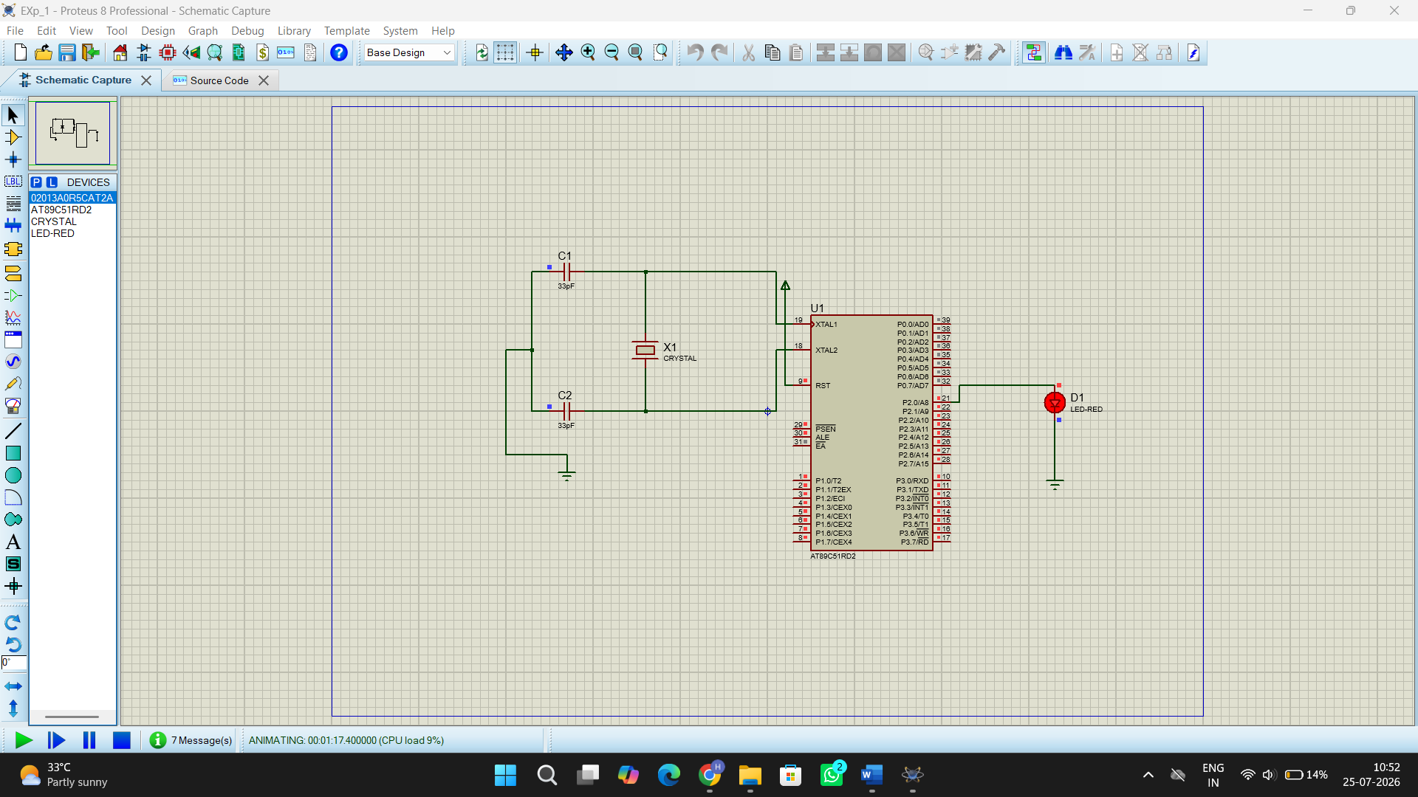
Exp No: 2

AIM:
GENERATION OF SQUARE WAVE USING PROTEUS

To write an assembly language program to Generate square wave using AT89C51.

PROGRAM
ORG 0000H UP: SETB P2.0
ACALL DELAY CLR P2.0 ACALL DELAY SJMP UP
DELAY: MOV R4,#35 H1:MOV R3,#255 H2:DJNZ R3,H2
DJNZ R4,
H1 RET
END

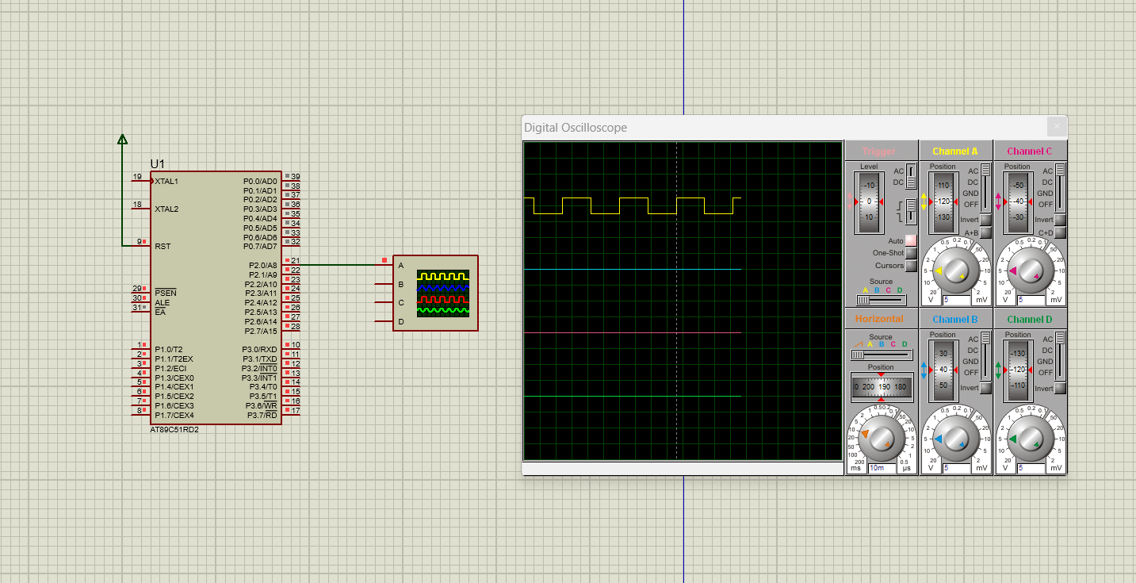

Exp No: 3: STEPPER MOTOR USING AT89C51 USING PROTEUS

AIM:
To write an assembly language program for Stepper Motor Using AT89C51 using Keil and Proteus

PROGRAM:
ORG 0000H
UP: MOV P2,#09H ACALL DELAY MOV P2,#0CH ACALL DELAY MOV P2,#06H ACALL DELAY MOV P2,#03H ACALL DELAY SJMP UP DELAY:MOV R4,#18 H1:MOV R3,#255 H2:DJNZ R3,H2 DJNZ R4,H1
RET END

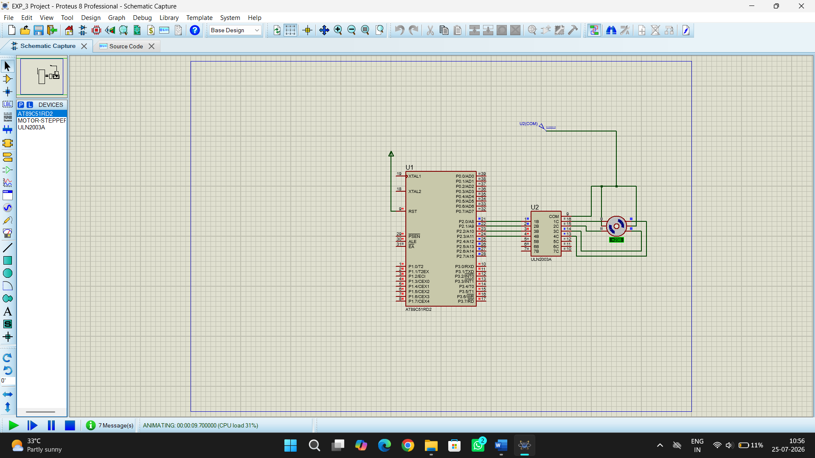

Exp No: 4

7 SEGMENT DISPLAY USING AT89C51 USING PROTEUS

AIM:
To write an assembly language program for 7 Segment Display Using AT89C51 using Keil and Proteus

PROGRAM:
ORG 000H UP:MOV P2,#0C0H ACALL DELAY MOV P2,#0F9H ACALL DELAY MOV P2,#0A4H ACALL DELAY MOV P2,#0B0H ACALL DELAY MOV P2,#99H ACALL DELAY MOV P2,#92H ACALL DELAY MOV P2,#82H ACALL DELAY MOV P2,#0F8H ACALL DELAY MOV P2, #80H ACALL DELAY MOV P2,#90H ACALL DELAY

DELAY: MOV R5,#10 H1:MOV R4,#180 H2:MOV R3,#255 H3:DJNZ R3,H3 DJNZ R4,H2
DJNZ R5,H1 RET
END
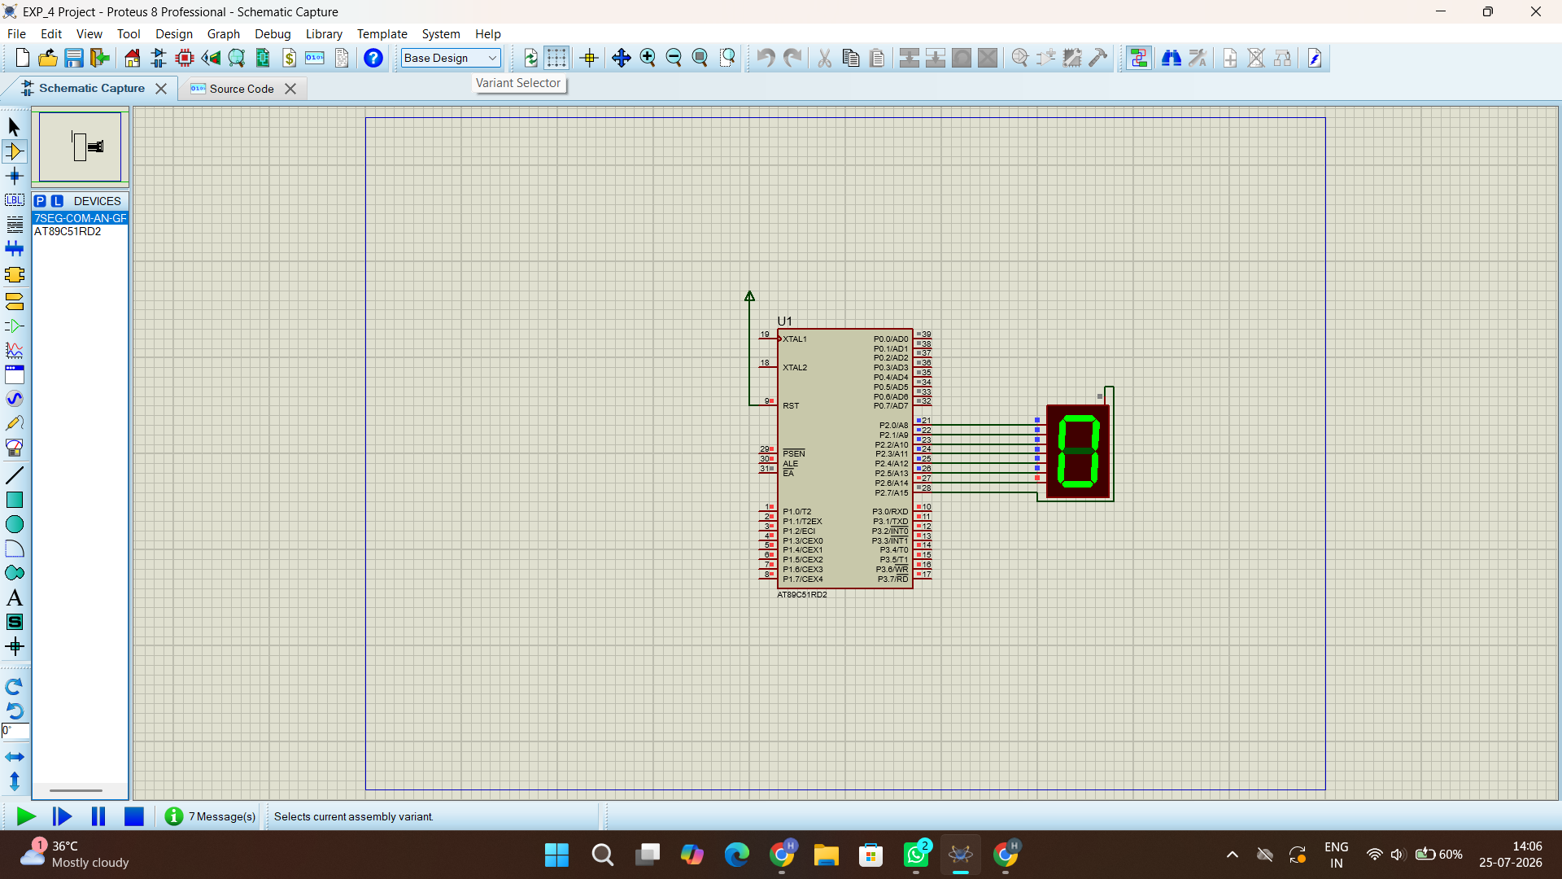

Exp No: 5

ARDUINO BASED MANUAL ELECTRONIC COUNTER USING PROTEUS

AIM:
To write an Embedded C program for Manual Electronic counter using Arduino IDE and Proteus

PROGRAM:
int x0,x1,x2,x3,x4,x5,x6,x7,x8,x9; int delay_time=200;

void setup() {
//configure pin2 as an input and enable the internal pull-up resistor pinMode(12, INPUT_PULLUP);
pinMode(1,OUTPUT); pinMode(2,OUTPUT);
pinMode(3,OUTPUT); pinMode(4,OUTPUT); pinMode(5,OUTPUT); pinMode(6,OUTPUT); pinMode(7,OUTPUT);

}
void loop() {
//read the pushbutton value into a variable int sensorVal = digitalRead(12);

if (sensorVal == LOW) { x0=true;
}
while(x0){ zero();
sensorVal = digitalRead(12); if (sensorVal == LOW) {
x1=true; x0=false;
}
}
while(x1){ one();
sensorVal = digitalRead(12); if (sensorVal == LOW) {
x2=true; x1=false;
}
}
while(x2){ two();
sensorVal = digitalRead(12); if (sensorVal == LOW) { x3=true; x2=false;
}
}
while(x3){ three();
sensorVal = digitalRead(12); if (sensorVal == LOW) { x4=true; x3=false;

}
}
while(x4){ four();
sensorVal = digitalRead(12); if (sensorVal == LOW) { x5=true; x4=false;
}
}
while(x5){ five();
sensorVal = digitalRead(12); if (sensorVal == LOW) { x6=true; x5=false;
}
}
while(x6){ six();
sensorVal = digitalRead(12); if (sensorVal == LOW) { x7=true; x6=false;
}
}
while(x7){ seven();
sensorVal = digitalRead(12); if (sensorVal == LOW) { x8=true; x7=false;
}
}
while(x8){

eight();
sensorVal = digitalRead(12); if (sensorVal == LOW) { x9=true; x8=false;
}
}
while(x9){ nine();
sensorVal = digitalRead(12); if (sensorVal == LOW) {
x0=true; x9=false;
}
}

}

void zero()
{
for(int i=1;i<7;i++)
{
digitalWrite(i,HIGH); digitalWrite(7,LOW);
}
delay(delay_time);
}

void one()
{
digitalWrite(1,LOW); digitalWrite(2,HIGH);

digitalWrite(3,HIGH); digitalWrite(4,LOW); digitalWrite(5,LOW); digitalWrite(6,LOW); digitalWrite(7,LOW); delay(delay_time);
}
void two()
{
digitalWrite(1,HIGH); digitalWrite(2,HIGH); digitalWrite(3,LOW); digitalWrite(4,HIGH); digitalWrite(5,HIGH); digitalWrite(6,LOW);
digitalWrite(7,HIGH); delay(delay_time); }

void three()
{
digitalWrite(1,HIGH); digitalWrite(2,HIGH); digitalWrite(3,HIGH); digitalWrite(4,HIGH); digitalWrite(5,LOW); digitalWrite(6,LOW);
digitalWrite(7,HIGH); delay(delay_time); }

void four()
{

digitalWrite(1,LOW); digitalWrite(2,HIGH); digitalWrite(3,HIGH); digitalWrite(4,LOW); digitalWrite(5,LOW); digitalWrite(6,HIGH); digitalWrite(7,HIGH);
delay(delay_time);
}

void five()
{
digitalWrite(1,HIGH); digitalWrite(2,LOW); digitalWrite(3,HIGH); digitalWrite(4,HIGH); digitalWrite(5,LOW);
digitalWrite(6,HIGH); digitalWrite(7,HIGH); delay(delay_time); }

void six()
{
digitalWrite(1,HIGH); digitalWrite(2,LOW); digitalWrite(3,HIGH); digitalWrite(4,HIGH); digitalWrite(5,HIGH); digitalWrite(6,HIGH); digitalWrite(7,HIGH); delay(delay_time);

}
void seven()
{
digitalWrite(1,HIGH); digitalWrite(2,HIGH); digitalWrite(3,HIGH); digitalWrite(4,LOW); digitalWrite(5,LOW);
digitalWrite(6,LOW); digitalWrite(7,LOW); delay(delay_time); }

void eight()
{
digitalWrite(1,HIGH); digitalWrite(2,HIGH); digitalWrite(3,HIGH); digitalWrite(4,HIGH); digitalWrite(5,HIGH); digitalWrite(6,HIGH); digitalWrite(7,HIGH); delay(delay_time);
}

void nine()
{
digitalWrite(1,HIGH); digitalWrite(2,HIGH); digitalWrite(3,HIGH); digitalWrite(4,HIGH); digitalWrite(5,LOW);

digitalWrite(6,HIGH); digitalWrite(7,HIGH); delay(delay_time);
}

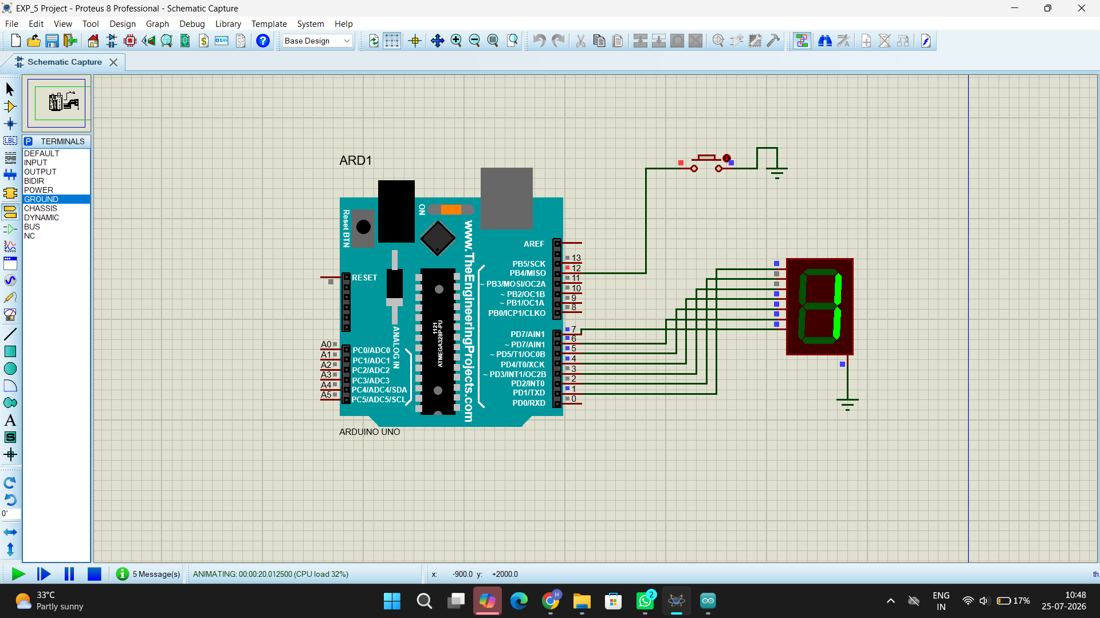

Exp No: 6
ARDUINO TO 16x2 LCD DISPLAY USING PROTEUS

AIM:
To write an Embedded C program to interface Arduino Uno and 16 x 2 LCD display using Arduino Uno and Proteus

PROGRAM:
Arduino to 16x2 LCD Display using Proteus #include <LiquidCrystal.h>
LiquidCrystal lcd (7, 8, 9, 10, 11, 12);
// your PWM numbers may be different void setup() {
lcd.begin(16, 2);
lcd.print("put your message here");

}

void loop () {

for (int i=0; 1<13; i++)
}

lcd.scrollDisplayLeft(); delay(700);

}
}

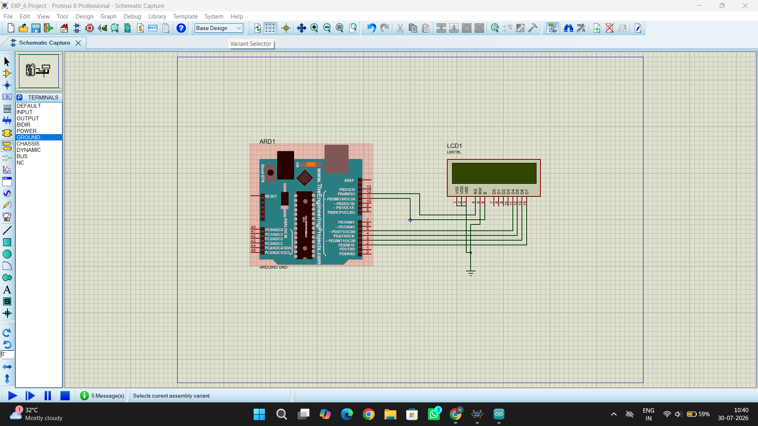

Exp No: 7

SERIAL COMMUNICATION USING ARDUINO WITH PROTEUS
AIM:
To write an Embedded C program for serial communication using Arduino Uno and Proteus

PROGRAM:
void setup()
{
Serial.begin(9600); // send and receive at 9600 baud
}

int number = 0; void loop()
{
Serial.print("Number is "); Serial.println(number); // print the number delay(500); // delay half second between numbers number++; // to the next number
}

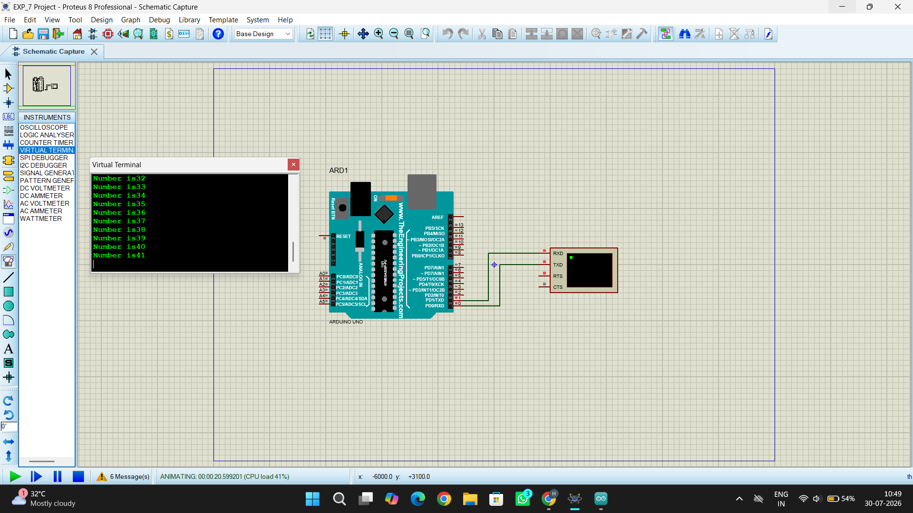

Exp No: 8

GAS SENSOR MQ-2 IN PROTEUS USING ARDUINO
AIM:
To write an Embedded C program for interfacing Gas Sensor MQ-2 using Arduino Uno and Proteus

PROGRAM:
#define GreenLed 13 #define Sensor A0

void setup(){ pinMode(13,OUTPUT); pinMode(12,OUTPUT); pinMode(A0,INPUT);
Serial.begin(9600);
}
void loop() {
int value = analogRead(A0);
Serial.print("Analogic Value coming from the sensor : "); Serial.println(value);
delay(100); if(value>600){ digitalWrite(13,HIGH);
}
else{ digitalWrite(13,LOW);

}
delay(20);
}
Code for MQ6 sensor:
int mq6Pin = A0; // MQ-5 analog pin connected to A0

void setup() { Serial.begin(9600);
}

void loop() {
int sensorValue = analogRead(mq5Pin); Serial.print("MQ5 Sensor Value: "); Serial.println(sensorValue); delay(1000); // 1-second delay
}

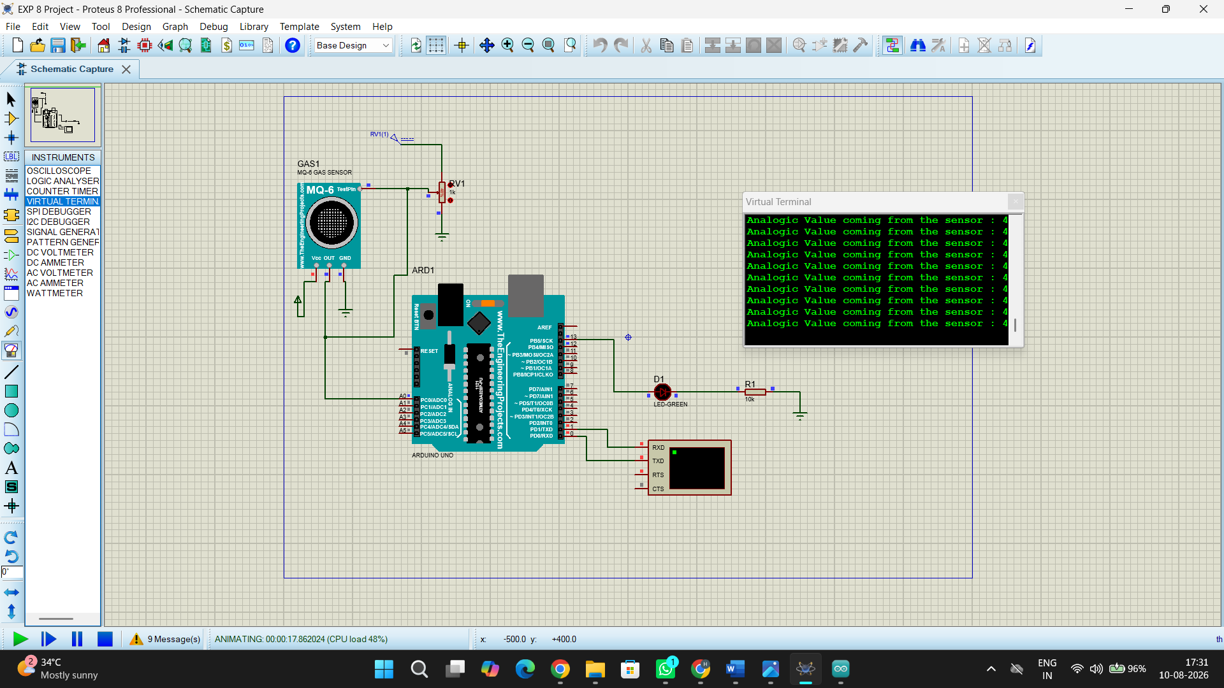

Exp No: 9

ULTRASONIC SENSOR IN PROTEUS USING ARDUINO
AIM:
To write an Embedded C program for interfacing Ultrasonic Sensor using Arduino Uno and Proteus
PROGRAM:
// Program Sketch int trig = 10;
int echo = 9; long duration; int cm;
void setup() {
// put your setup code here, to run once: pinMode(trig, OUTPUT);
pinMode(echo,INPUT);

Serial.begin(9600);

}
void loop() { // Sketch to calculate ultrasonic distance digitalWrite(trig, LOW);
delayMicroseconds(10); digitalWrite(trig, HIGH); delayMicroseconds(10); digitalWrite(trig, LOW); delayMicroseconds(10); duration = pulseIn(echo, HIGH); cm = (duration/2) * 0.034;
// Print Value on Serial Monitor Serial.print(" Distance = "); Serial.print(cm); Serial.println(" cm");
}

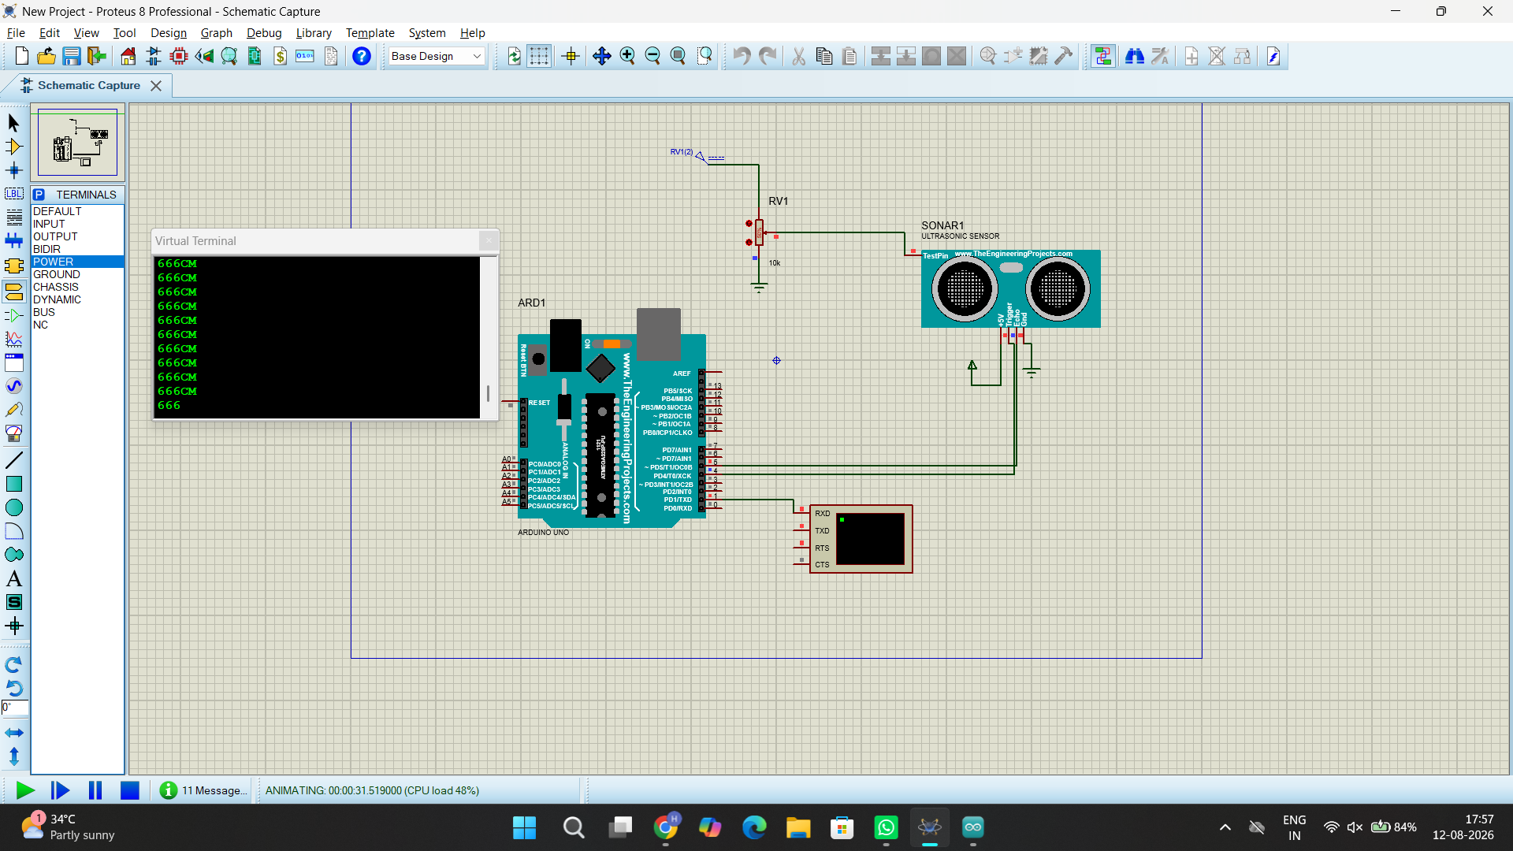
Exp No: 10

PIR SENSOR IN PROTEUS USING ARDUINO
AIM:
To write an Embedded C program for interfacing PIR Sensor using Arduino Uno and Proteus

PROGRAM:
int Status = 13; // Digital pin D6
int sensor = 12; // Digital pin D7
void setup() {
Serial.begin(9600);
pinMode(sensor, INPUT); // declare sensor as input
pinMode(Status, OUTPUT); // declare LED as output
}
void loop() {
long state = digitalRead(sensor);
Serial.println(state) ;
if(state == HIGH) {
digitalWrite (Status, HIGH);
Serial.println("Motion detected!");
delay(1000);
}
else {
digitalWrite (Status, LOW);
Serial.println("Motion absent!");
delay(1000);
}
}
